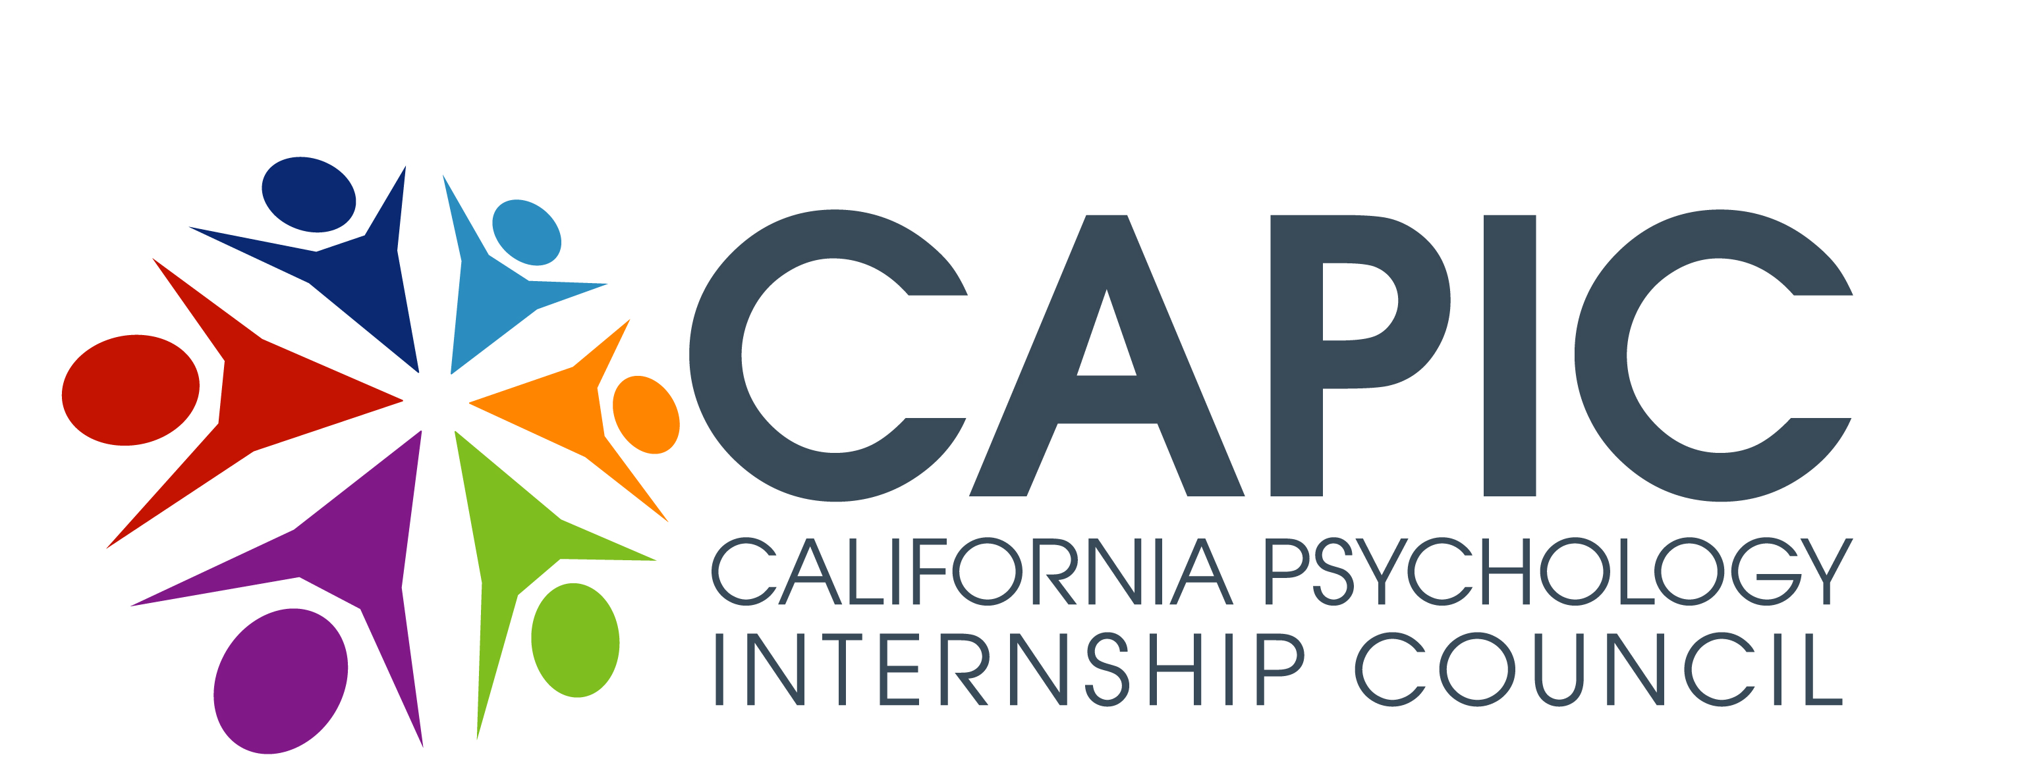
CAPIC
100 Ellinwood Way
Suite N275h
Pleasant Hill, CA 94523

925.969.4550
www.capic.net

New Predoc/Postdoc Member Applications, Status Change Requests & QA Site Visits:

Basic How-To Steps for CAPIC Board members for reviewing online materials
for a prospective new member application, status change request, or QA visit.

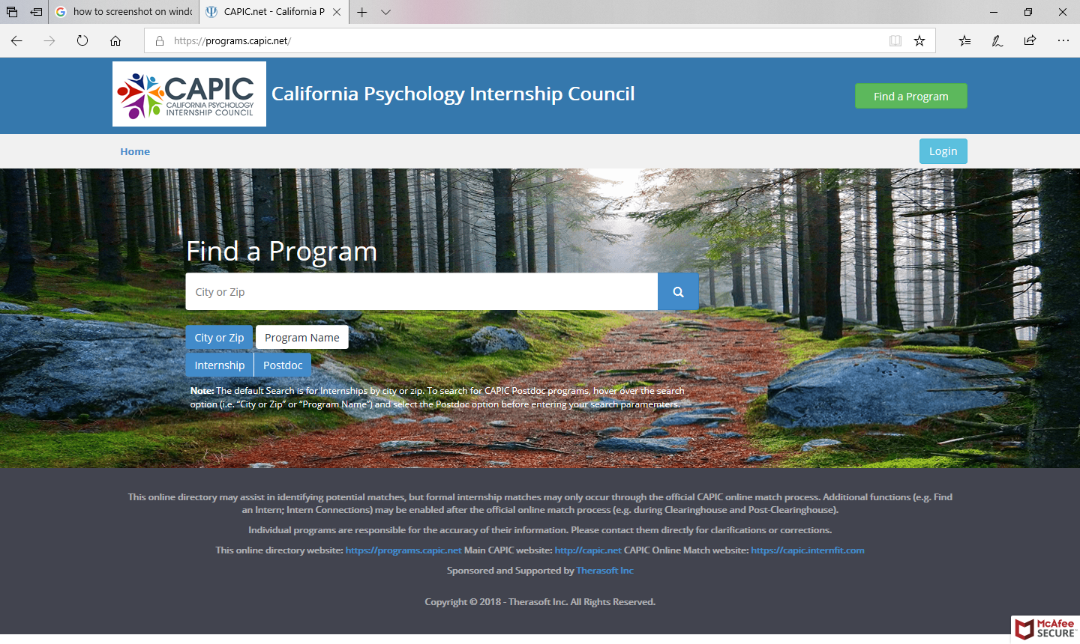
1. Login at the top of our online directory platform page.

Here is the direct link: https://programs.capic.net/

Use the applicant program’s own login credentials to gain access to their profile (the CAPIC office will provide login information)
- Note: Please be careful NOT to edit their profile information or delete any uploaded documents.

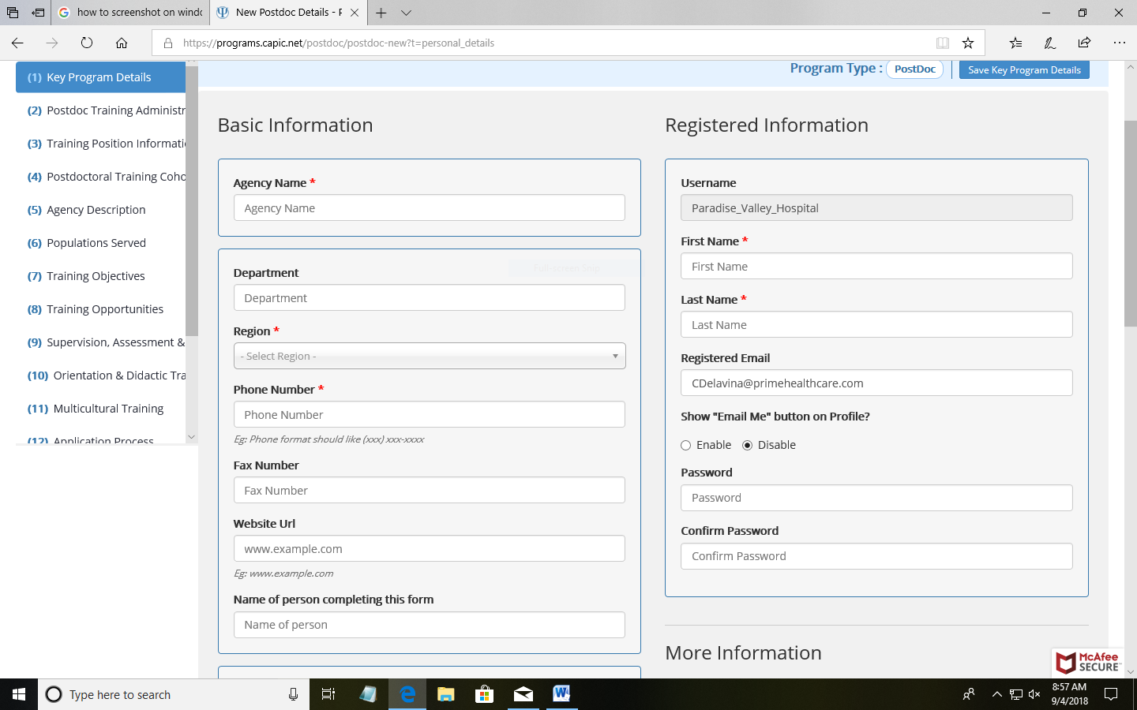
2. The following page will then appear.
Use the left-hand column to navigate through pages of the online profile and review the pages and the uploaded documents.

You will need to review both the online profile and the supplemental documents (e.g. CV’s of supervisors, training manual, etc.) in order to verify the consistency of what’s being reported.

- Note: The Supplemental docs can be accessed by scrolling down to the last page on the left hand scroll menu.

3. Review all pages making sure they are filled in correctly, complying with the CAPIC intern or postdoc membership criteria, as appropriate, and that the supporting documents matches the information provided in the profile.

Here is an example of a program’s supplemental doc page:

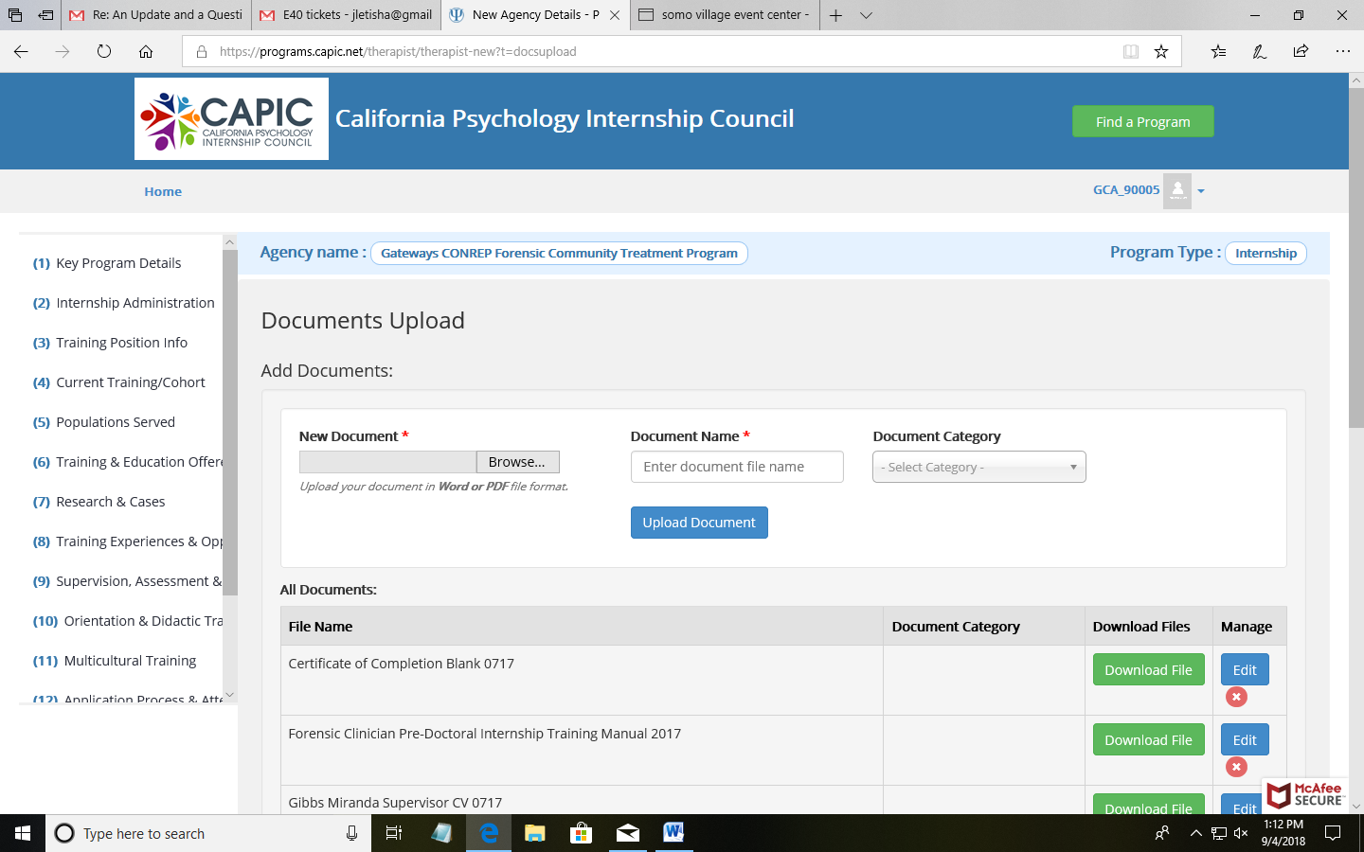
- All programs should have the following documents uploaded here:
  - CVs of all supervisors (primary and delegated)
  - Training Manual
  - Didactic Schedule
  - Program’s grievance procedures
  - Program/Agency Brochure
  - Internship-specific Brochure (if applicable, especially for large organizations)
  - Internship certificate of completion with the word “Psychology”
  - HT-2-Year Narrative, if applicable.

NOTE: Internship programs sometimes combine some of these materials together (e.g. Training Manual with Didactic Schedule and HT-2Year narrative).

Please note that the CAPIC office is not able to judge the substance of these supplemental documents. Board members must make that determination. For example, the program may have a training manual and didactic schedule uploaded, but the CAPIC office does not have the qualifications to know whether the substance in these documents is sufficient for the program.

- With the full profile and supplemental documents as resources, complete the Rating sheet (Internship, Postdoc).
  - If the program is an existing CAPIC member and is only requesting approval of a status change (e.g. from HT-1 year to FT), complete a Status change request form, instead of the Rating Sheet.

- Separately arrange a site visit with the program, ideally at a time when trainees will be present. During or after the site visit, complete the Site visit form. Follow the procedures outlined in the QA Site Visit Training Presentation for reviewing new applications, status change requests and site visits. Please be sure to send your completed documentation to the CAPIC office when done.
  - NOTE: If a program is a consortium or has multiple sites, a review and/or site visit of each location should be conducted.

- For doctoral academic programs (DAP), CAPIC maintains no online profile and no site visit is conducted. Instead, board members use the DAP Review template to review materials publicly posted (e.g. on program website) or provided by the program Dean or Director of Clinical Training (DCT) to ensure the program complies with CAPIC criteria for Doctoral Academic Program members.

- These QA Review & Site Visit blank forms are posted publicly on the CAPIC’s Quality Assurance webpage.
  - This internal How-To document and the QA Site Visit Training Presentation are also available on our website.

- If you have any questions, contact the Membership Chair or the CAPIC office. Thanks!

